SPENDING YOUR FARMER’S MARKET BENEFITS
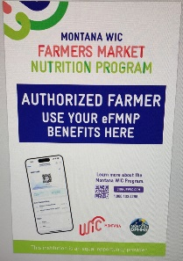
- Spend ONLY at Approved WIC Farms – looks for this sign
(if it is not displayed, please ask them to put it up or reference below who our WIC farmers are at the Helena Farmers Market)

- FM Benefits can be spent at our 2 local farmer markets OR at any approved farmer within the state (approved farmers have the “Montana WIC Authorized Farmer” Sign)
  - Saturday: Helena Farmers Market on Fuller St, 9:00 AM to 1:00 PM
  - Tuesday: East Helena Farmers Market at Main Street Park 3:00 PM to 6:00 PM. Starts July 27th
These are the farmers who accept WIC FM benefits:

Highland Produce Hicks Garden

Broken Wheel Farm West Mont Farm and Garden

- FM Benefits need to be spent – Last day to spend is Saturday, September 27th, 2025. If you are not able or choose not to use all your FM benefits, please return them to the office so we can
re-distribute them to other WIC families.

- You can spend Farmers Market benefits all at once or space them out. They just need to be spent before the end of the WIC Farmers Market Season.

- FM Benefits are for the 2025 Farmers Market season and are not issued monthly

- Spend on fruits, vegetables, and herbs only - no baked goods or plants (refer to the Approved Farm Direct Food List)

- Each eligible participant gets $30 FM benefits for the Farmers Market 2025 season – They are NOT issued monthly

- Lost, Damaged, or Stolen Farmer Market Benefits CANNOT be re-issued

