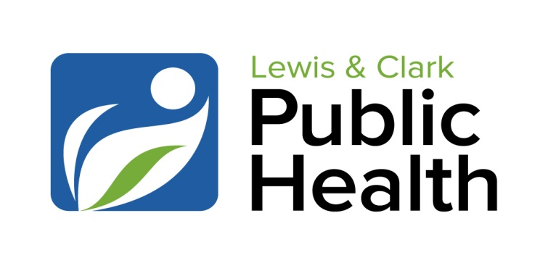
Division of Environmental Health and Disease Prevention
1930 Ninth Avenue, Helena MT 59601
Phone: 406-457-8900
Fax: 406-457-8990
http://www.lccountymt.gov/health.html

January 2025

TO: Food Service Owners and Managers

RE: Food Safety Management Systems (Active Managerial Control)

All types of food service businesses, including bars, coffee shops, convenience stores, food trucks, hot dog carts, temporary food booths, manufacturers, cafes, and full-service restaurants, are required by state law to assure the safety of the food or drinks that they provide to the public. The following are requirements, from the Montana Food Code, for all food service establishments, from facilities that only sell packaged, refrigerated food to the most complex restaurants:

- Person In Charge (PIC). Food service businesses are required to have a designated Person in Charge (PIC) at all times the facility is serving/selling/making food or drinks.
- Training. All staff must have training in food safety as it relates to their role in food/drink handling.
  - At least one currently Certified Food Protection Manager is required for any food service facility doing complex food preparation. For facilities with basic operations, a food handler course may be sufficient.
  - The PIC does not necessarily have to be a Certified Food Protection Manager but must be knowledgeable in food safety as it relates to the food or drinks that are served. The PIC must be knowledgeable about foodborne illnesses and how they are transmitted. For restaurants, mobile food units, and cafes, the PIC must have knowledge equivalent to that of a Certified Food Protection Manager.
  - Facilities may do in house training.
  - Food handler courses are available online for staff who work under the supervision of a Certified Food Protection manager.
- Monitoring. The Person in Charge is responsible for monitoring to ensure safe food. The Person in Charge can also train employees to do monitoring. It is common practice for employees to do monitoring, but the PIC must verify that it is being done. This includes:
  - Food Temperatures (cooking, reheating, cold holding, hot holding, cooling, receiving, whatever is applicable to the type of facility)
    - This means actively monitoring food temperatures, often multiple times a day.
    - Log sheets are highly recommended to help track temperatures and aid with verification. Templates are available.
  - Employee Health and Hygiene (hand washing, glove use, not working when ill)
    - An employee health policy must be in place, with staff actively aware of the entire policy. There should be ongoing training about this policy. Example policies are available.
      - The food code requires employees to report certain illnesses to the PIC.
      - The food code requires the PIC to report certain illnesses to the health department.
    - The PIC must actively monitor employee health and hygiene.
    - Employees must be trained on proper hand washing and hygiene.
    - Employees must be trained to avoid all bare hand contact with food.
  - Equipment Function
    - This includes refrigerators, dish washers, plumbing, cooking and heating equipment. Equipment must function per manufacturer’s specifications.
  - Cleaning and Sanitizing
    - The PIC must monitor to be sure that cleaning and sanitizing of dishes and surfaces is being done correctly.
    - Sanitizer concentrations must be monitored.
  - All other aspects of a food service operation that could affect food safety
    - Examples are pest control and allergen awareness
- Corrective Action. It is the duty of the PIC, or someone that they have designated, as specified in the food code, to address any issues that affect food safety. This means the PIC or their designee must take appropriate corrective action to mitigate any risk that food could cause illness.
  - Examples of corrective action are moving food to a colder unit, discarding food that is out of temperature, switching to using time as a control on food that is out of temperature, reheating food that is out of temperature.
  - Other examples are calling for repair of a refrigerator or hot holding unit, adjusting a thermostat on a refrigerator, discarding food after bare hand contact, doing onsite training of an employee after observing improper hand washing and sanitizing surfaces the employee touched with unclean hands.

The main goal of your food safety management system is to prevent illness and injury by making sure that the food or drink that is provided to the consumer is safe. A food safety management system can also cut down on waste because it is a proactive system that can help prevent problems. This approach to food safety is called Active Managerial Control (AMC) and there are some excellent resources available to operators to help implement a system. Written documentation such as task checklists and log sheets are crucial for implementing a successful system.

Active Managerial Control resources can be found at:
https://www.maricopa.gov/5114/Food-Restaurants
https://www.fairfaxcounty.gov/health/food/active-managerial-control/resources
https://www.retailfoodsafetycollaborative.org/tools/amc-class/

Food Safety Resources
Lewis and Clark Public Health has many food safety resources available on our website. These range from information posters on food safety, standard operating procedures (SOPs), log sheets, and self-inspection check lists. Please see our website at: __________Fill this in with website link___________________
If you have any questions about implementing a food safety management system, about the resources, about the food code, or anything else, please contact your inspector. The Montana Food Code can be found at:
https://dphhs.mt.gov/publichealth/ehfs/RetailFood/index
Information about upcoming Certified Food Protection Manager classes can be found at:
https://dphhs.mt.gov/publichealth/ehfs/RetailFood/foodmanagertrainings/index

Sincerely, The Licensed Establishment Team at Lewis and Clark Public Health (aka health inspectors)

